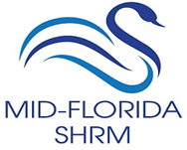

Chapter # 151 Chapter Name: Mid-Florida SHRM

I hereby designate the above named chapter as my primary chapter for SHRM membership coding purposes. I understand that:
- This in no way precludes membership in other chapters.
- This allows SHRM to list my membership to this chapter for financial support program purposes only.
Please type or print:
NAME____________________________________ SHRM MEMBER ID#_________________
(You must be a current national member of the Society for Human Resource Management to complete this form.)
COMPANY NAME_____________________________________________________________
ADDRESS___________________________________________________________________
___________________________________________________________________
CITY/STATE/ZIP______________________________________________________________
PHONE# ____________________________________________________________________
FAX ________________________________________________________________________
E-MAIL _____________________________________________________________________

Date: ___________ Member’s Signature: ________________________________________
(Member must sign to validate)
Please email to: Natalie Jones, VP of Membership
natalie.jones@publix.com

