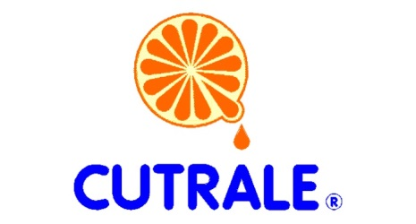

Cutrale Citrus Juices USA, Inc., is seeking a Recruiter for our Auburndale, FL location. We are looking for a high-volume recruiter who is looking for a company they can grow with.
The ideal candidate will have a strong recruiting background with a deep understanding of the recruiting process to be able to take a strategic approach to evaluate, create and implement new processes and procedures.
As a Recruiter you will source, screen and select candidates from both internal and external sources.
ESSENTIAL DUTIES:
- Proactively develop candidate pipelines through traditional and innovative sourcing methods, including social media avenues, job fairs and any emerging technology-based methods.
- Establish and maintain relationships within the community and local colleges.
- Maintain a pipeline of candidates.
- Use social media, job boards, current systems and data to actively source candidates.
- Oversee the new hire process
EDUCATION/EXPERIENCE:
- Bachelor’s degree preferred but not required
- Five plus years of large-scale, high-volume recruiting experience required, preferably within manufacturing
- Five plus years in Human Resources department as a Generalist, Specialist and/or Recruiter
- Social media sourcing for recruitment purposes
The Cutrale family started in the citrus business in the 1960’s. The Company’s headquarters are in Araraquara, Brazil. Expanding to the United States in 1996, Cutrale bought processing plants in Auburndale and in Leesburg from the Coca-Cola Company. The Company’s mission is to be a worldwide consistent high quality source of orange juice, its products and services, adding value to the citrus business, while respecting the community and the environment. The essential objective of Cutrale is to provide the highest quality products and highest service level to our customers, while being the most efficient juice in the citrus industry. Cutrale strives to provide each employee with a quality of environment conducive to growth, development and opportunity.
Please send resume to yolivas@cutrale.com or apply directly on our website at: https://cutraleusa.applicantpro.com/jobs/

